Abstract

[Draw your reader in with an engaging abstract. It is typically a short summary of the document.   
When you’re ready to add your content, just click here and start typing.]



john in wells

[Email address]

[Document subtitle]

# Assessment –

# Research & Questioning

|  |  |  |  |
| --- | --- | --- | --- |
| Name of Student | Boi Dinh TRAN | ID | 18190 |

Contents

Assessment – 1

Research & Questioning 1

***Instructions:*** 1

***Business Scenario*** 1

***Task 1: Determine support areas*** 2

***Task 2: Identify stakeholders*** 3

***Task 3: Develop support procedures*** 4

***Task 4: Assign Support Personnel*** 6

***Task 5: Short Answer Questions*** 6

***Task 6: Multiple Choice Questions*** 7

Index 12

View My Web Support: <https://stephybdtran.github.io/ECBR2022/>

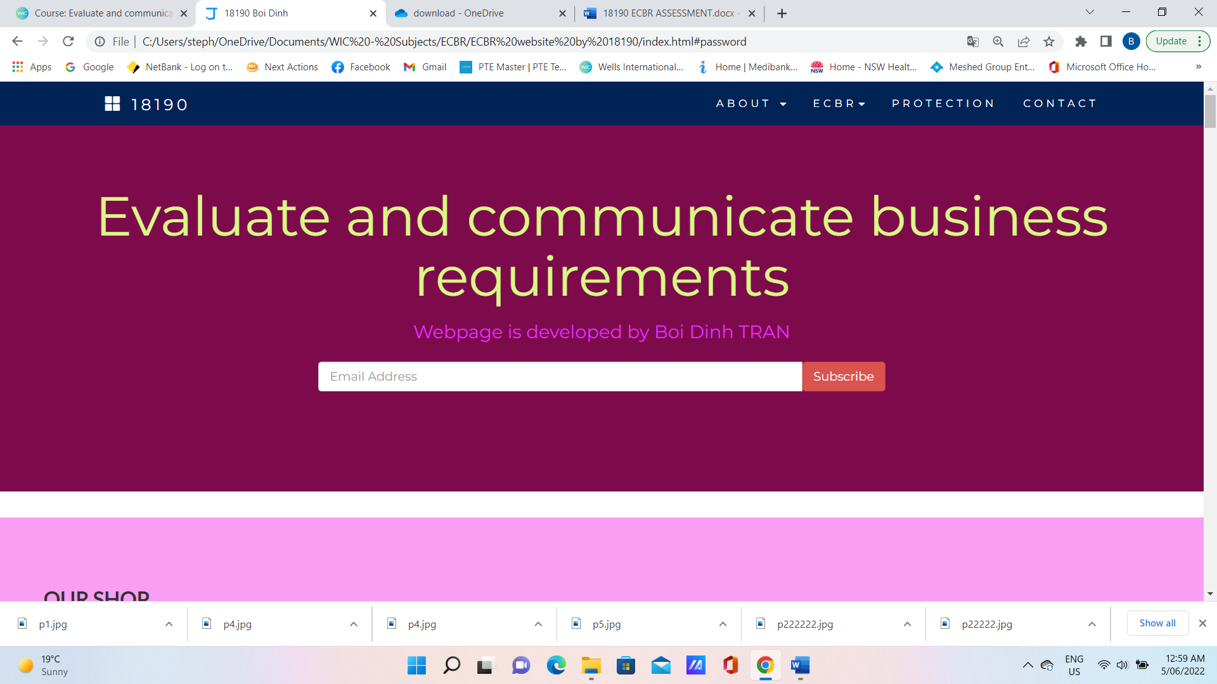

#### *Instructions:*

This assessment is to be completed individually. In this assessment you will be working through a number of written tasks based on case scenarios or research that relate directly to each element of competency for this cluster. Outlined below is information on how each of the tasks relates the element of competency covered.

Learn how to make Google Form: <https://www.youtube.com/watch?v=3rDaLLJ_r8g&t=327s>

Your tasks:

#### *Business Scenario*

D&K Books Pty Ltd is a bookstore owned by Mr. Dean Kerr. The business occupies two levels of an office building connected by escalators and lifts. D&K Books employs approximately six sales staff, one operation manager, two administrative officers, a bookkeeper and a marketing manager. They have an Ethernet network consisting of ten PCs (Intel I3 Desktop cloned), two switches, a router and three printers. They use the QuickBooks software to manage their entire business, including sales, inventory, ordering, accounts receivable, accounts payable, payroll and employee management. They also have two EFTPOS terminals one on each floor.

D&K Books has a Linux server that stores all of the data including the QuickBooks database. The server is backed up to tape regularly. They also have a website (hosted on an Australian ISP’s server, dynamic and static pages using asp.net) on which customers can browse the product catalogue and view current specials. They also lease a telephone system from Live Telecoms. The PABX (phone system) consists of a main switchboard and five remote phones with three incoming lines and a message-on-hold queue system.

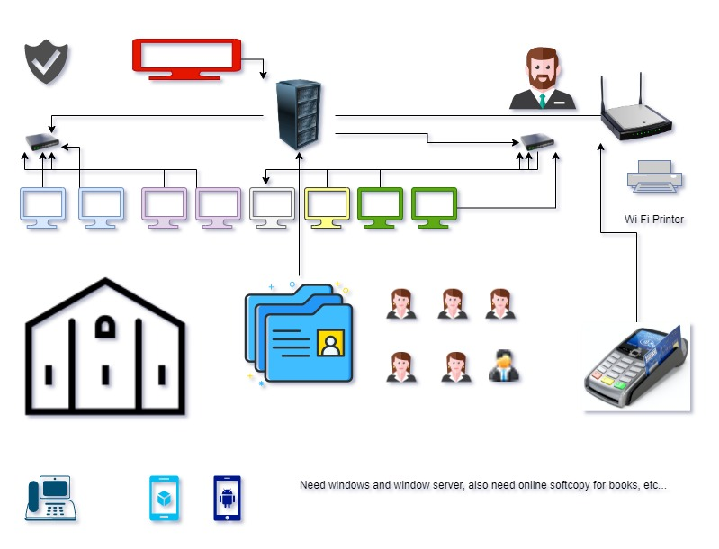

Good network system, you need setup at least:

|  |  |
| --- | --- |
| Hard ware | Software |
| Server X 1 | Window Server |
| Computer X 8 | Windows |
| Printer X 1 | SQL server |
| Telephone X 8 | Virus Protection |
| Modern X 2 | MS office |
| Network Cable | Eftpos machine More… |

#### *http://imapwebsolutions.com/wp-content/uploads/2014/07/linux-dedicated-server.pngTask 1: Determine support areas*

Identify information technology (HW and SW) and list the technology in use in D&K Books and consider the following:

* What sort of support does the technology require?
* Who is likely to provide this support?
* Does the support arrangement already exist?

Present your answer in a table such as the one below:

|  |  |  |  |  |
| --- | --- | --- | --- | --- |
| **Technology** | **Description** | **Support Required** | **Provider** | **Support Already exists? (Yes/No)** |
| QuickBooks Software | software that keeps track of all accounts, stock, GST, etc. | customisation, training, upgrades, bug fixes (patching), user support | [www.intuit.com.au](http://www.intuit.com.au)  online to find more | No |
| PC’s | Intel I3 Desktop cloned | upgrades, repairs, troubleshooting, maintenance, backup, customisation, network to link |  | No. Need find one person to do this job |
| **Server**  IconExperience » V-Collection » Server Icon | Linux Server with tape backup  May need upgrade to hard disk backup | User account management, security policy implementation, home folder management, permissions management, backup and restore, operating system patching, software installation |  | No |
| EFTPOS | Easy to use | No need | shop | Yes |
| Telephone system | Low cost | Phone company | Telstra | Yes |
| Website | Low cost | Yes | Godaddy | Yes |
| Network | wireless | No external | No | No |

Please review my website:

#### *Task 2: Identify stakeholders*

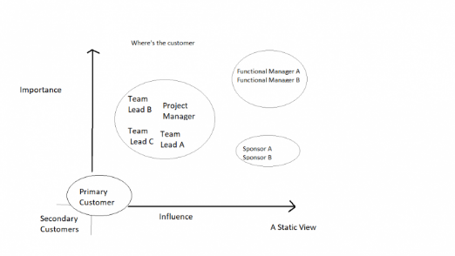

Identify stakeholders related in D&K Books system

A stakeholder is a party with an interest in an enterprise; stakeholders in a corporation include investors, employees, customers, and suppliers.

All the staffs (the business owner, the relevant manager, the local workers and the remote workers) are stakeholders.

A stakeholder's primary role is to help a company meet its strategic objectives by contributing their experience and perspective to a project. They can also provide necessary materials and resources.

#### *Task 3: Develop support procedures*

1. Describe one positive and one negative experience you have had when seeking assistance from a telecommunication company, an ISP or a computer supplier. Your experience may be via telephone, email or even voice recognition.

|  |  |  |
| --- | --- | --- |
| Type | Positive | Negative |
| Telephone | Easy to get answer | Waste time to call back when the phone line is busy |
| Email | Document, Picture, Words or any media, Send to many people at the same time | Have to wait |
| Go to company | Face to face get answer | Cost time and money on trip |
| Fax | Document, Photos, Letters | Cost money |

1. Using the experiences described above please answer the following questions.



* 1. What support aspects were professional and/or unprofessional?

As adjectives the difference between professional and unprofessional. is that professional is of, pertaining to, or in accordance with the (usually high) standards of a profession while unprofessional is unbecoming of a professional; hence inappropriate in the workplace.

* 1. How long did the support process take?
  2. Were the steps logical?
  3. Did they solve your problem?
  4. Was the call deflected to another area?

|  |  |  |
| --- | --- | --- |
| Items | professional | unprofessional |
| What support aspects | Friendly, Listening | Not what know your customer |
| How long | Very quick | Waiting and waiting |
| Steps logical | Yes | No |
| Solve | Good | Can not |
| Another area | If has, need solve | If has, do not care |

Using feedback form or Google survey form.

Here is the very simple survey demo:

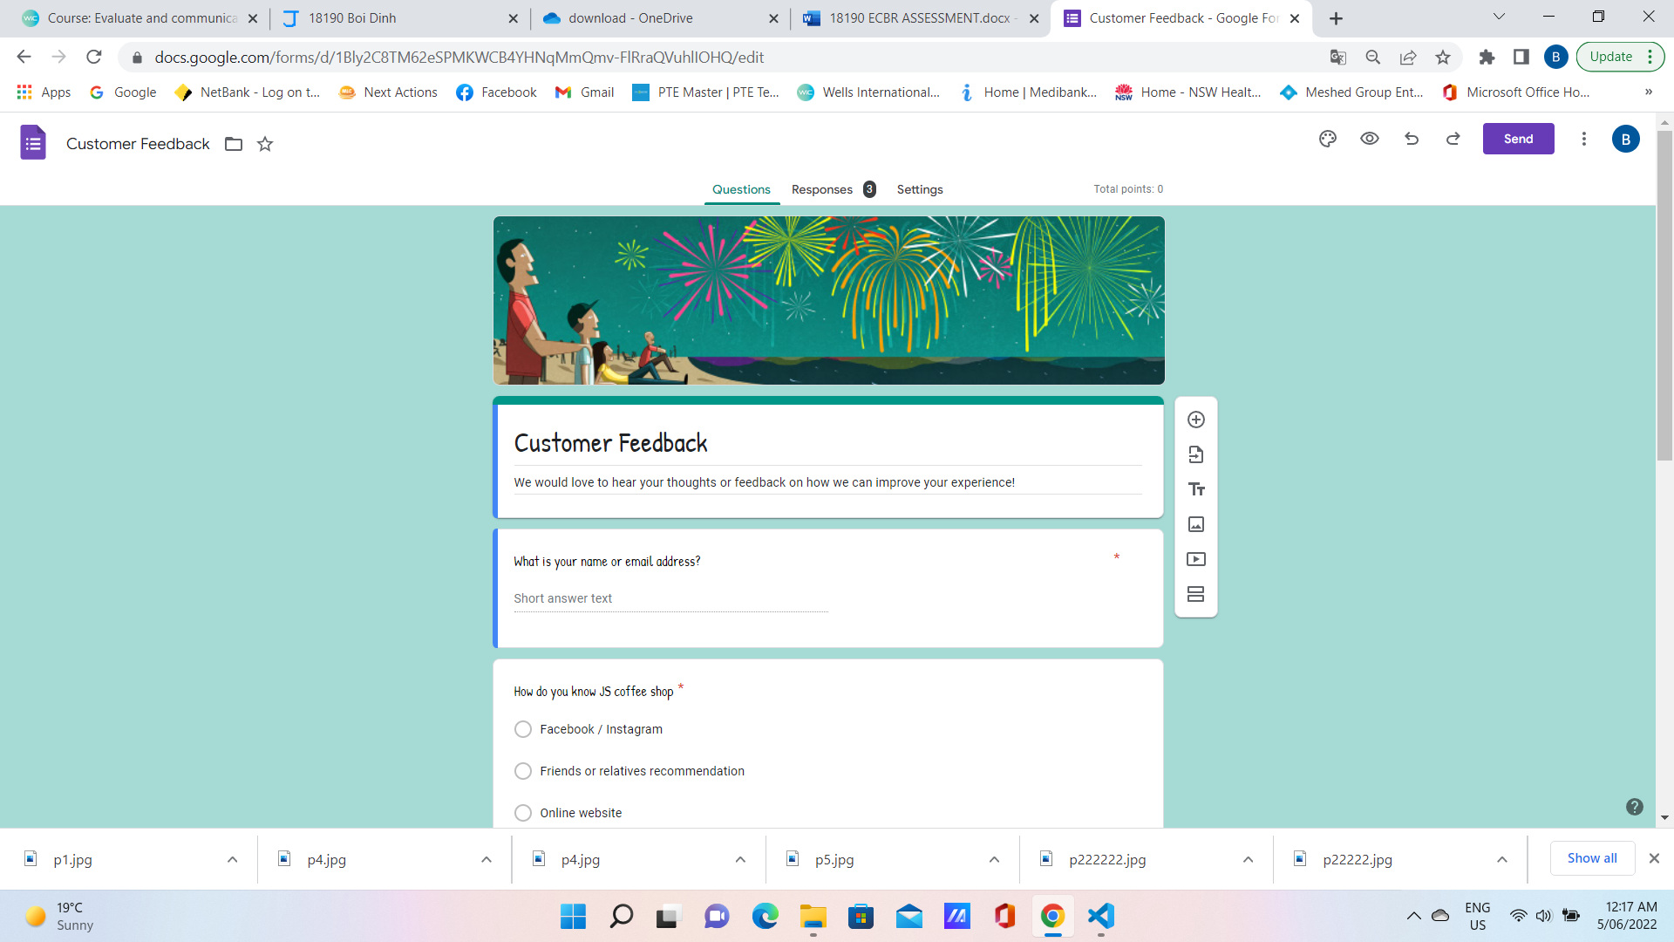

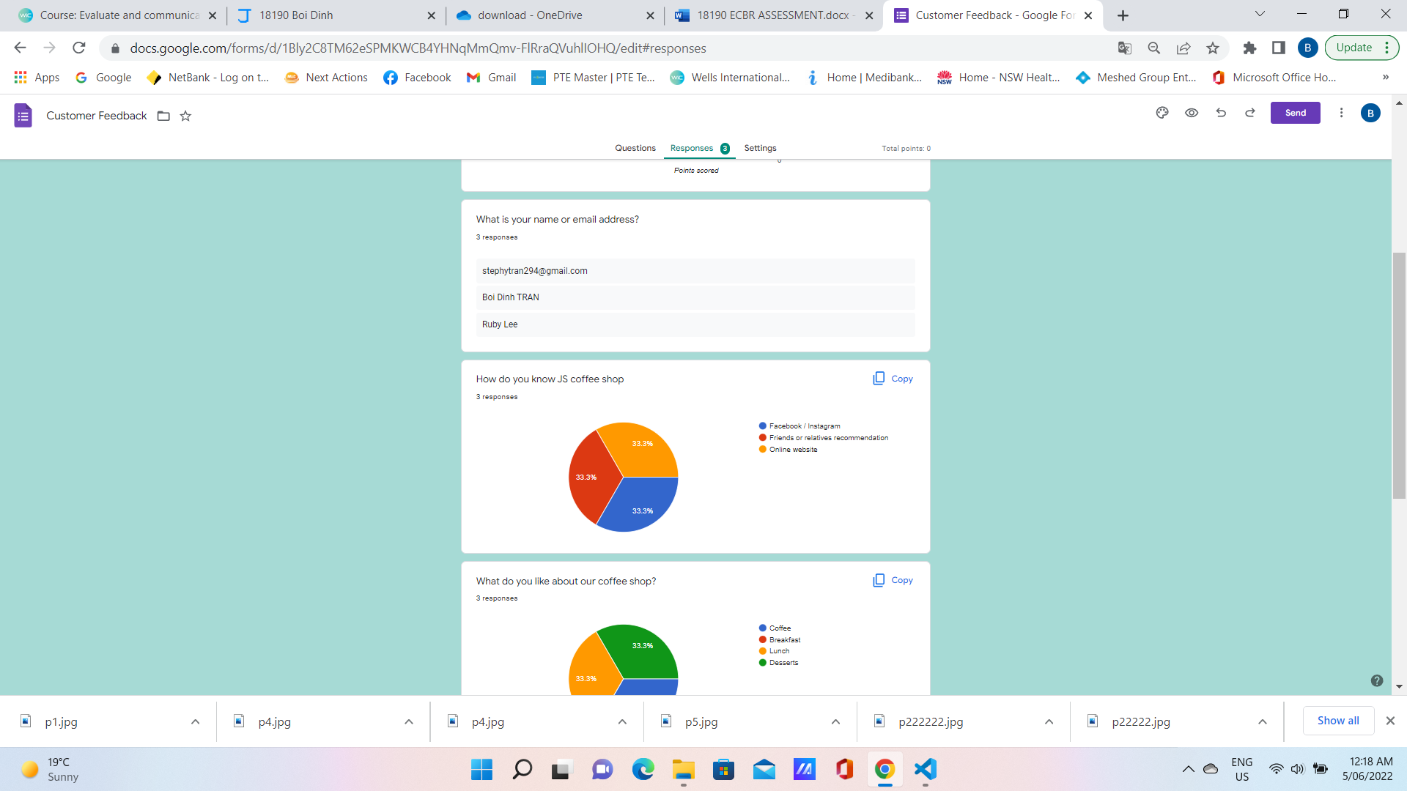

After I tested my friends, I could get nice response like:

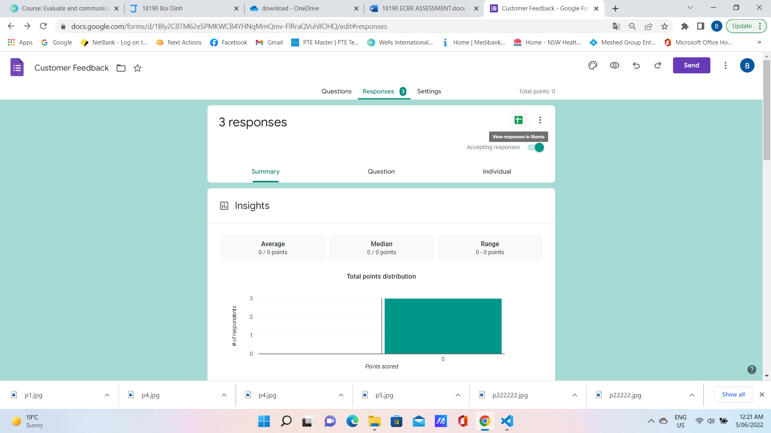

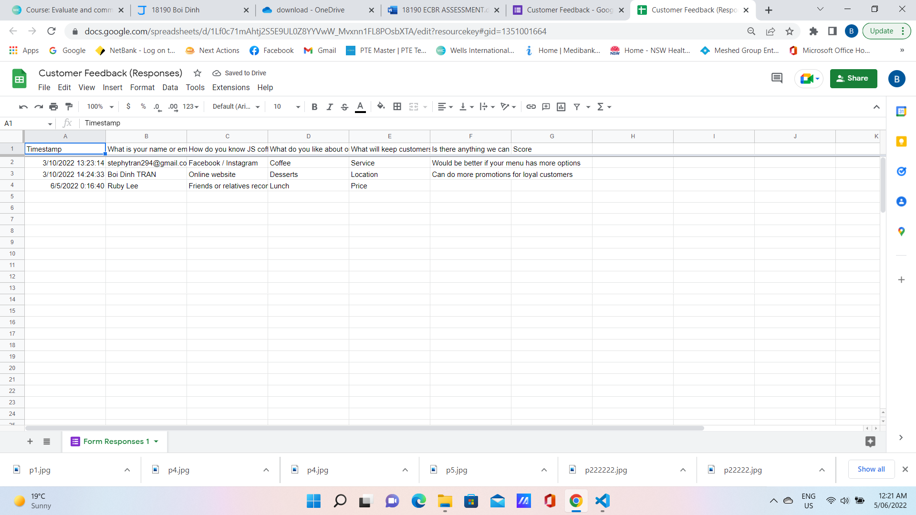

Or using link string: <https://forms.gle/TBbS3r2fx7WUiN7K9>

#### *Task 4: Assign Support Personnel*

Classify the following into soft skills and technical skills. Your answer should take the form of a table shown below.

|  |  |  |
| --- | --- | --- |
| **Skill** | **Soft skill** | **Technical skill** |
| A knowledge of Linux | X |  |
| The ability to work under pressure | X |  |
| The administration of Windows 2008 Server |  | X |
| The ability to formulate network and IT policies |  | X |
| The ability to write network documentation |  | X |
| The ability to give presentations | X |  |

#### *Task 5: Short Answer Questions*

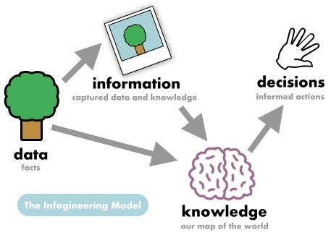

1. Explain the relationship between data, information and knowledge.

Information is created when data are processed, organized, or structured to provide context and meaning.

Information is essentially processed data.

Knowledge is what we know.

1. What is quantitative data and how can you use it.

Quantitative data is used when a researcher needs to quantify a problem, and answers questions like “what,” “how many,” and “how often.” This type of data is frequently used in math calculations, algorithms, or statistical analysis

1. What is qualitative data and how can you use it.

Qualitative data describes qualities or characteristics. It is collected using questionnaires, interviews, or observation, and frequently appears in narrative form. For example, it could be notes taken during a focus group on the quality of the food at Cafe Mac, or responses from an open-ended questionnaire.

1. Give an example of how quantitative and qualitative data can be used in conjunction with each other

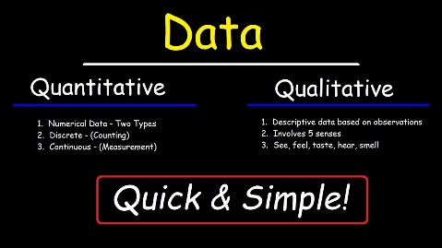

1. What sort of methods could you use to determine client requirements for a website design and key information sources?

Website requirements are a list of necessary functions, capabilities, or characteristics related to your website and the plans for creating it.

1. Give some examples of client requirements for a website design

* Fonts look good
* 24 hours work
* Easy to update
* Upgrade is free
* Website contents
* Images
* Colors

#### *Task 6: Multiple Choice Questions*

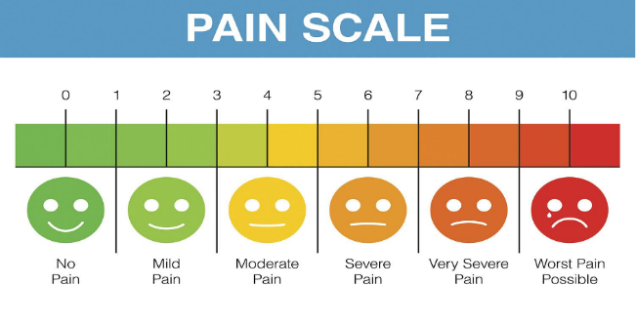

1. Generally, how many points should a rating scale have?
   1. Five
   2. Four
   3. Ten
   4. Somewhere from 4 to 11 points Reason

Web refer: <https://lumoa.me/blog/rating-scale>

A rating scale is a closed-end survey question that is used to evaluate how survey responders feel about a particular product or statement.

Comment: I like 10 points. It is easy and clear to get the best feedback way.

1. What is the problem(s) with this set of response categories to the question “What is your current age?”

* 1-5
* 5-10
* 10-20
* 20-30
* 30-40
  1. The categories are not mutually exclusive
  2. The categories are not exhaustive
  3. Both a and b are problems Reason
  4. There is no problem with the above set of response categories

1. You should mix methods in a way that provides complementary strengths and no overlapping weaknesses. This is known as the fundamental principle of mixed research.
   1. True Reason
   2. False
2. According to the text, questionnaires can address events and characteristics taking place when?
   1. In the past (retrospective questions)
   2. In the present (current time questions)
   3. In the future (prospective questions)
   4. All of the above
3. Which of the following are principles of questionnaire construction?
   1. Consider using multiple methods when measuring abstract constructs
   2. Use multiple items to measure abstract constructs
   3. Avoid double-barrelled questions
   4. All of the above
   5. Only b and c
4. Which of these is not a method of data collection?
   1. Questionnaires
   2. Interviews
   3. Experiments
   4. Observations
5. Secondary/existing data may include which of the following?
   1. Official documents
   2. Personal documents
   3. Archived research data
   4. All of the above
6. An item that directs participants to different follow-up questions depending on their response is called a ____________.
   1. Response set
   2. Probe
   3. Semantic differential
   4. Contingency question

Reason: Contingency questions are questions that are only to be answered by some subgroup(s) of respondents. For example, "If you own your home, how long have you owned it?" Contingency questions may have either closed-ended or open-ended response options.

1. Which of the following terms best describes data that were originally collected at an earlier time by a different person for a different purpose?
   1. Primary data
   2. Secondary data

Reason: Secondary data is the data that has already been collected through primary sources and made readily available for researchers to use for their own research. It is a type of data that has already been collected in the past.

* 1. Experimental data
  2. Field notes

1. Researchers use both open-ended and closed-ended questions to collect data. Which of the following statements is true?
   1. Open-ended questions directly provide quantitative data based on the researcher’s predetermined response categories
   2. Closed-ended questions provide quantitative data in the participant’s own words
   3. Open-ended questions provide qualitative data in the participant’s own words

Reason: Open-ended questions are questions that do not provide participants with a predetermined set of answer choices, instead allowing the participants to provide responses in their own words. Open-ended questions are often used in qualitative research methods and exploratory studies.

* 1. Closed-ended questions directly provide qualitative data in the participants’ own words

1. Open-ended questions provide primarily ______ data.
   1. Confirmatory data
   2. Qualitative data

Reason: Qualitative data describes qualities or characteristics. It is collected using questionnaires, interviews, or observation, and frequently appears in narrative form. For example, it could be notes taken during a focus group on the quality of the food at Cafe Mac, or responses from an open-ended questionnaire.

* 1. Predictive data
  2. None of the above

1. Which of the following is true concerning observation?
   1. It takes less time than self-report approaches
   2. It costs less money than self-report approaches
   3. It is often not possible to determine exactly why the people behave as they do Reason
   4. All of the above
2. Qualitative observation is usually done for exploratory purposes; it is also called ___________ observation.
   1. Structured
   2. Naturalistic
   3. Complete
   4. Probed
3. When constructing a questionnaire, it is important to do each of the following except ______.
   1. Use "leading" or "loaded" questions Reason
   2. Use natural language
   3. Understand your research participants
   4. Pilot your test questionnaire
4. Another name for a Likert Scale is a(n):
   1. Interview protocol
   2. Event sampling
   3. Summated rating scale

Reason: Likert's Summated Rating Scale is a five point scale on which respondents express their attitude i.e. agree to disagree towards the statements. Likert's scale is more convenient and easy to use than Thurston's scale so Likert scale is widely used by the researchers in measuring attitude.

* 1. Ranking

1. Which of the following is not one of the six major methods of data collection that are used by educational researchers?
   1. Observation
   2. Interviews
   3. Questionnaires
   4. Checklists
2. The type of interview in which the specific topics are decided in advance but the sequence and wording can be modified during the interview is called:
   1. The interview guide approach

Reason:General interview guide approach – the guide approach is intended to ensure that the same general areas of information are collected from each interviewee; this provides more focus than the conversational approach, but. still allows a degree of freedom and adaptability in getting information from the interviewee.

* 1. The informal conversational interview
  2. A closed quantitative interview
  3. The standardized open-ended interview

1. Which one of the following in not a major method of data collection:
   1. Questionnaires
   2. Interviews
   3. Secondary data
   4. Focus groups
   5. All of the above are methods of data collection
2. A question during an interview such as “Why do you feel that way?” is known as a:
   1. Probe
   2. Filter question
   3. Response
   4. Pilot
3. A census taker often collects data through which of the following?
   1. Standardized tests
   2. Interviews
   3. Secondary data
   4. Observations
4. The researcher has secretly placed him or herself (as a member) in the group that is being studied. This researcher may be which of the following?
   1. A complete participant

Reason: This is a fully embedded researcher, almost like a spy. Here the observer fully engages with the participants and partakes in their activities. Participants aren't aware that observation and research is being conducted, even though they fully interact with the researcher.

* 1. An observer-as-participant
  2. A participant-as-observer
  3. None of the above

1. Which of the following is not a major method of data collection?
   1. Questionnaires
   2. Focus groups
   3. Correlational method

Reason: Here are the top six data collection methods:

* Interviews.
* Questionnaires and surveys.
* Observations.
* Documents and records.
* Focus groups.
* Oral histories.
  1. Secondary data

1. Which type of interview allows the questions to emerge from the immediate context or course of things?
   1. Interview guide approach
   2. Informal conversational interview

Reason: An informal interview is a job interview that takes place in a casual setting typically outside of an office, such as a café or pub. Taking an interview outside a traditional corporate environment helps put the interviewer and job applicant at ease so they can get to know each other better.

* 1. Closed quantitative interview
  2. Standardized open-ended interview

1. When conducting an interview, asking "Anything else?, What do you mean?, Why do you feel that way?," etc, are all forms of:
   1. Contingency questions
   2. Probes

Reason: Probing is asking follow-up questions when we do not fully understand a response, when answers are vague or ambiguous or when we want to obtain more specific or in-depth information.

* 1. Protocols
  2. Response categories

1. When constructing a questionnaire, there are 15 principles to which you should adhere. Which of the following is not one of those principles?
   1. Do not use "leading" or "loaded" questions
   2. Avoid double-barrelled questions
   3. Avoid double negatives
   4. Avoid using multiple items to measure a single construct

Reason:

1. A customer-based Service Level Agreement structure includes:
   1. An SLA covering all Customer groups and all the services they use
   2. SLAs for each service that are Customer-focused and written in business language
   3. An SLA for each service type, covering all those Customer groups that use that Service
   4. An SLA with each individual Customer group, covering all of the services they use

Reason: An SLA document typically consists of: An introduction to the SLA, what does this agreement propose. A Service description, what service this SLA supports, and details of the service. Mutual responsibilities, who's responsible for what part of the service.

1. Which of the following best describes the goal of Service Level Management?
   1. To maintain and improve IT service quality in line with business requirements

Reason: The purpose of Service Level Management is to ensure that all current and planned IT services are delivered to agreed achievable targets.

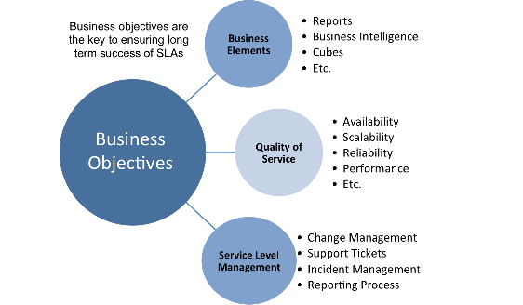

* 1. To provide IT services at the lowest possible cost by agreeing with Customers their minimum requirements for service availability and ensuring performance does not exceed these targets
  2. To provide the highest possible level of service to Customers and continuously improve on this through ensuring all services operate at maximum availability
  3. To ensure that IT delivers the same standard of service at the least cost

1. The process to implement SLAs comprises of the following activities in sequence:
   1. Draft SLAs, catalogue services, review underpinning contracts and OLAs, draft SLRs, negotiate, agree SLAs
   2. Draft SLAs, review underpinning contracts and OLAs, negotiate, catalogue services,
   3. Review underpinning contracts and OLAs, draft SLAs, catalogue services, negotiate, agree SLAs
   4. Catalogue services, establish SLRs, review underpinning contracts and OLAs, negotiate service levels, agree SLAs

Reason: Getting Started: Establishing An SLA · Understand the time commitment. Do not underestimate the time and commitment involved in this process.

1. Which of the following is an example of a service level agreement (SLA) between information systems support unit and a research unit in the laboratories of a large company?
   1. The maximum response time to get the system operational should it fail.
   2. The minimum ‘up-time’.
   3. The types of information that will be provided as standard.
   4. All of the above.

Reason

1. Some organisations bring a degree of formality to the internal customer concept by encouraging (or requiring) different parts of the operation to agree on:
   1. Internal service agreements
   2. Service level agreements

Reason: A service-level agreement (SLA) sets the expectations between the service provider and the customer and describes the products or services to be delivered, the single point of contact for end-user problems, and the metrics by which the effectiveness of the process is monitored and approved.

* 1. Formal provision agreements
  2. Delivery agreements

## Index

B

bookstore 1

C

categories 6

closed-ended 7

D

data collection 9

L

Linux server 2

N

network 1

O

open-ended 7

S

Service Level 9

service level agreement 10

service quality 10

soft skills 5

support 3

T

technology 2

telecommunications 3